Prak – justBuyUnique

(Web Development)

**Mini Project - 1**

**SYNOPSIS**

Department Of Computer Science Engineering & Applications

**Institute of Engineering & Technology**

**Submitted to :-** **Submitted by :-**

Mr. Sharad Gupta Aastha Gupta (19150004)

(Assistant Professor) Ayush Singh (191500202)

Kashish Varshney (191500387)

Priyansh Srivastav (191500607)

Rachit Gupta (191500614)

Page 1 of 12

ACKNOWLEDGEMENT

It gives us a great sense of pleasure to present the synopsis of the B.Tech Mini Project (Prak - justBuyUnique) undertaken during B.Tech IIIrd Year. This project in itself is going to be an acknowledgement to the inspiration, drive and technical assistance will be contributed to it by many individuals.

We owe Special debt of gratitude to **Mr. Sharad Gupta** , Assistant Professor Department of **CEA** , for providing us with an encouraging platform to develop this project , which thus helped us in shaping our abilities towards a constructive goal and for his constant support and guidance to our work.

His sincerity, thoroughness and perseverance has been a constant source of inspiration for us. We believe that he will shower us with all his extensively experienced ideas and insightful comments at different stages of the project & also taught us about the latest industry-oriented technologies.

We also do not like to miss the opportunity to acknowledge the contribution of all faculty members of the department for their kind guidance and co-operation.

**Aastha Gupta (19150004)**

**Ayush Singh (191500202)**

**Kashish Varshney (191500387)**

**Priyansh Srivastava (191500607)**

**Rachit Gupta (191500614)**

Page 2 of 12

Contents

|  |  |  |
| --- | --- | --- |
| Declaration ---------------------------------------------- | | (1) |
| Acknowledgement------------------------------------- | | (2) |
| Introduction--------------------------------------------- | | (4) |
| Motivation----------------------------------------------- | | (5) |
| Requirement Analysis | |  |
| • | Hardware Requirement---------------------- | (6) |
| • | Software Requirement----------------------- | (6) |
| Technology Used--------------------------------------- | | (7) |
| Picturization Of Our Model-------------------------- | | (8) |
| Future Scope------------------------------------------- | | (11) |
| References---------------------------------------------- | | (12) |

Page 3 of 12

**Introduction**

Prak is an Indian Based E-commerce website which is a go-to Trending B2B site for millions of makers of Handmade goods, vintage items and craft products . E-commerce is fast gaining ground as an accepted and used business paradigm. More and more business houses are implementing web sites providing functionality for performing commercial transactions over the web. Here we focus on digitally enabled commercial transactions among organizations and individuals. It is a Small Start-Up where people will come together to buy and sell unique items and will surely take advantage of it. It's Human Nature to Value the Creative Spirit. Nowadays, It is reasonable to say that the process of shopping on the web is becoming commonplace.

Page 4 of 12

**Motivation**

 In today’s world, online shopping is booming with the rise of the

internet. So, we came up with a unique and rare e-commerce

website where special handmade, vintage items can be bought or sold.

 In this pandemic many people lost their jobs and small businesses collapsed. Our website helps those people with creativity, artistic hand to sell their handmade items and earn money.

 People can also sell and buy vintage and unique items and earn money of their worth with 0% commission.

 This website supports small businesses . It will help sustain handicraft artists who are running out of business.

Page 5 of 12

**REQUIREMENT ANALYSIS**

**Hardware Requirement :-**

|  |  |  |
| --- | --- | --- |
| Hard Disk | : 100 MB upto 500 MB | |
| RAM | : | 1 GB |
| Processor | : | 1.6 GHz or faster processor |

**Software Requirements** :-

Operating System : Windows, Linux, MAC OS

User Interface : HTML , CSS , BOOTSTRAP

Database : MySQL

Programming Language : JAVASCRIPTS

Application Software : Visual Studio Code (version 1.61.0)

Web Browser : Google Chrome, Mozilla Firefox

Page 6 of 12

**Technology Used**

 **Web Development**

We will use Visual Studio Code, which is a streamlined code editor with support for development operations like debugging, task running, and version control. It aims to provide just the tools a developer needs for a quick code-build-debug cycle and leaves more complex workflows to fuller featured IDEs, such as Visual Studio IDE. So, we will use this platform for our project development.

 **HTML**

We will use HTML in Visual Studio code to design the structure of our project.

 **CSS**

We will use CSS in visual studio code to develop the front-end of our project.

 **JavaScript**

We will use JavaScript in visual studio code to develop the back-end of our project.

 **MySQL**

We will use MySQL as a database management system in our project.

Page 7 of 12

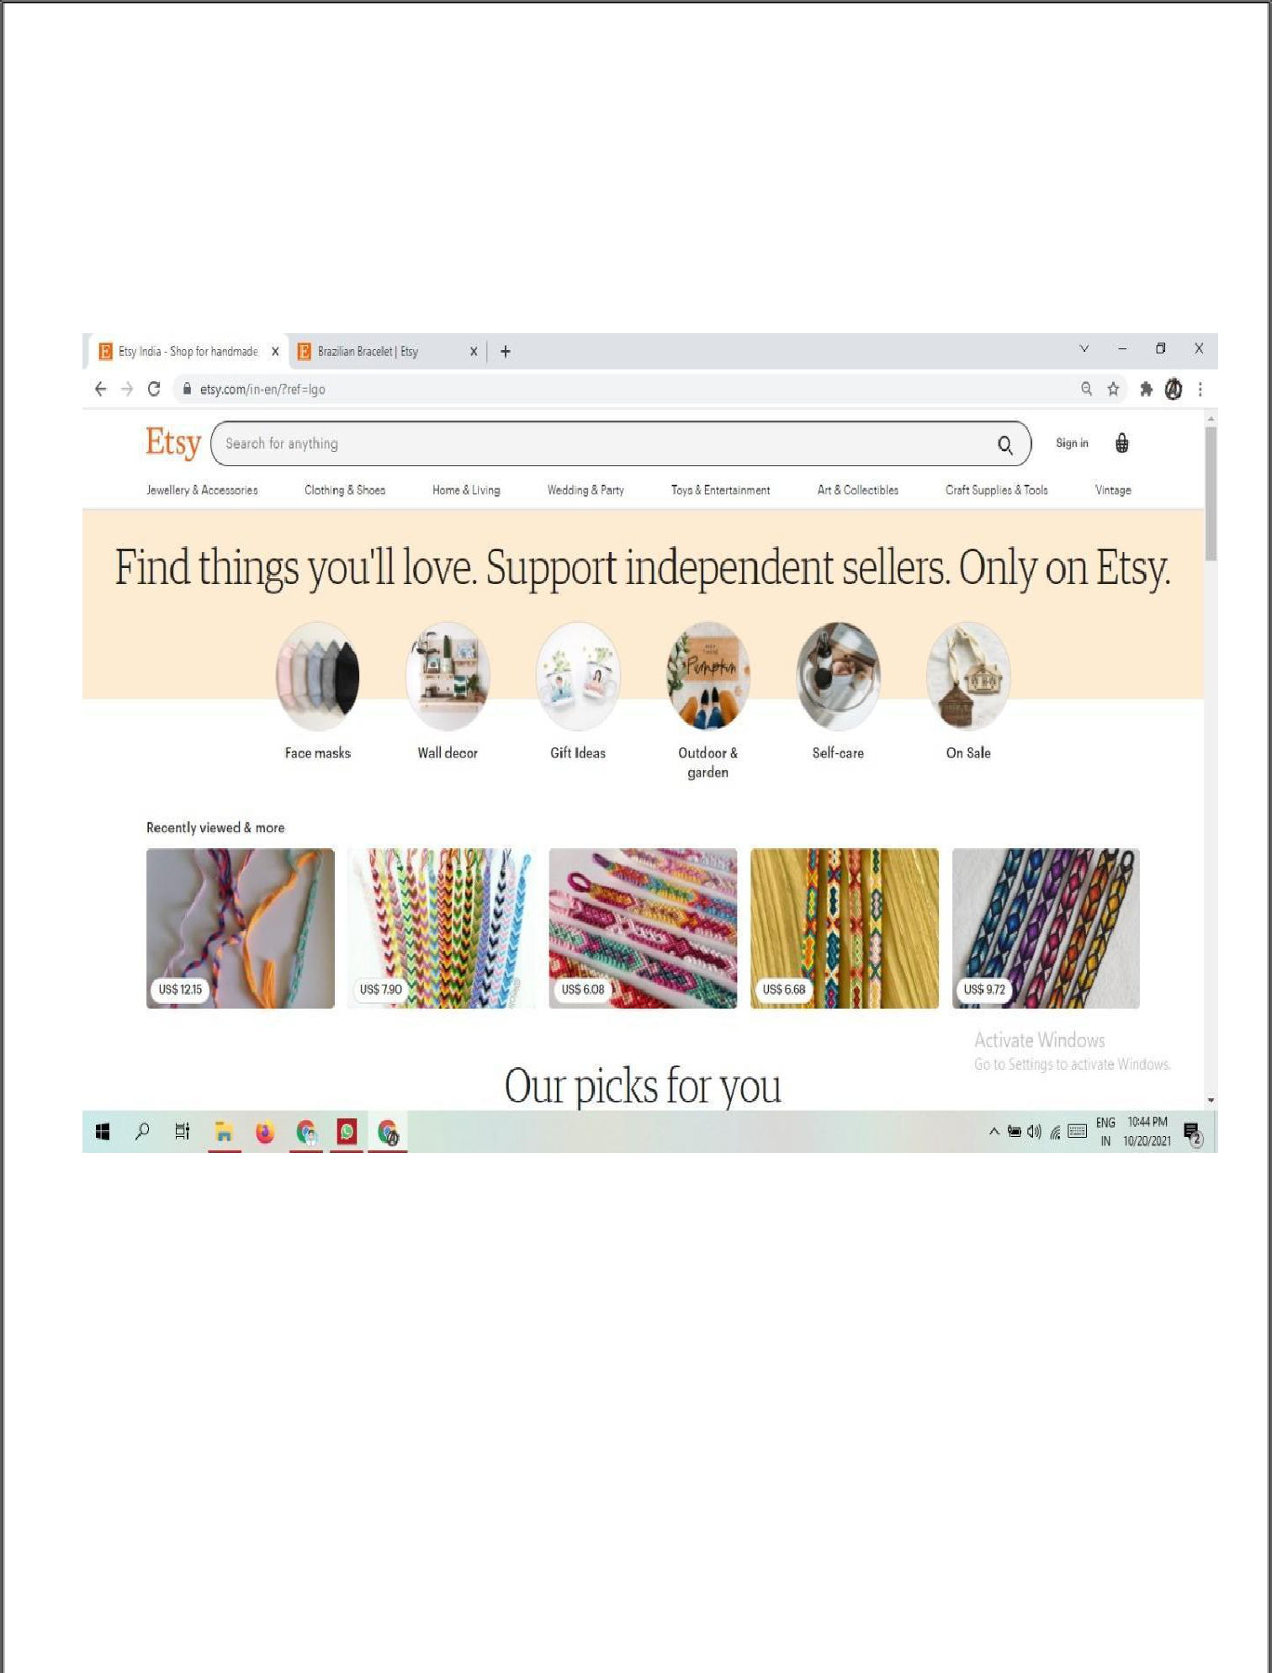**Picturization of Our Model**

(Header)

Page 8 of 12

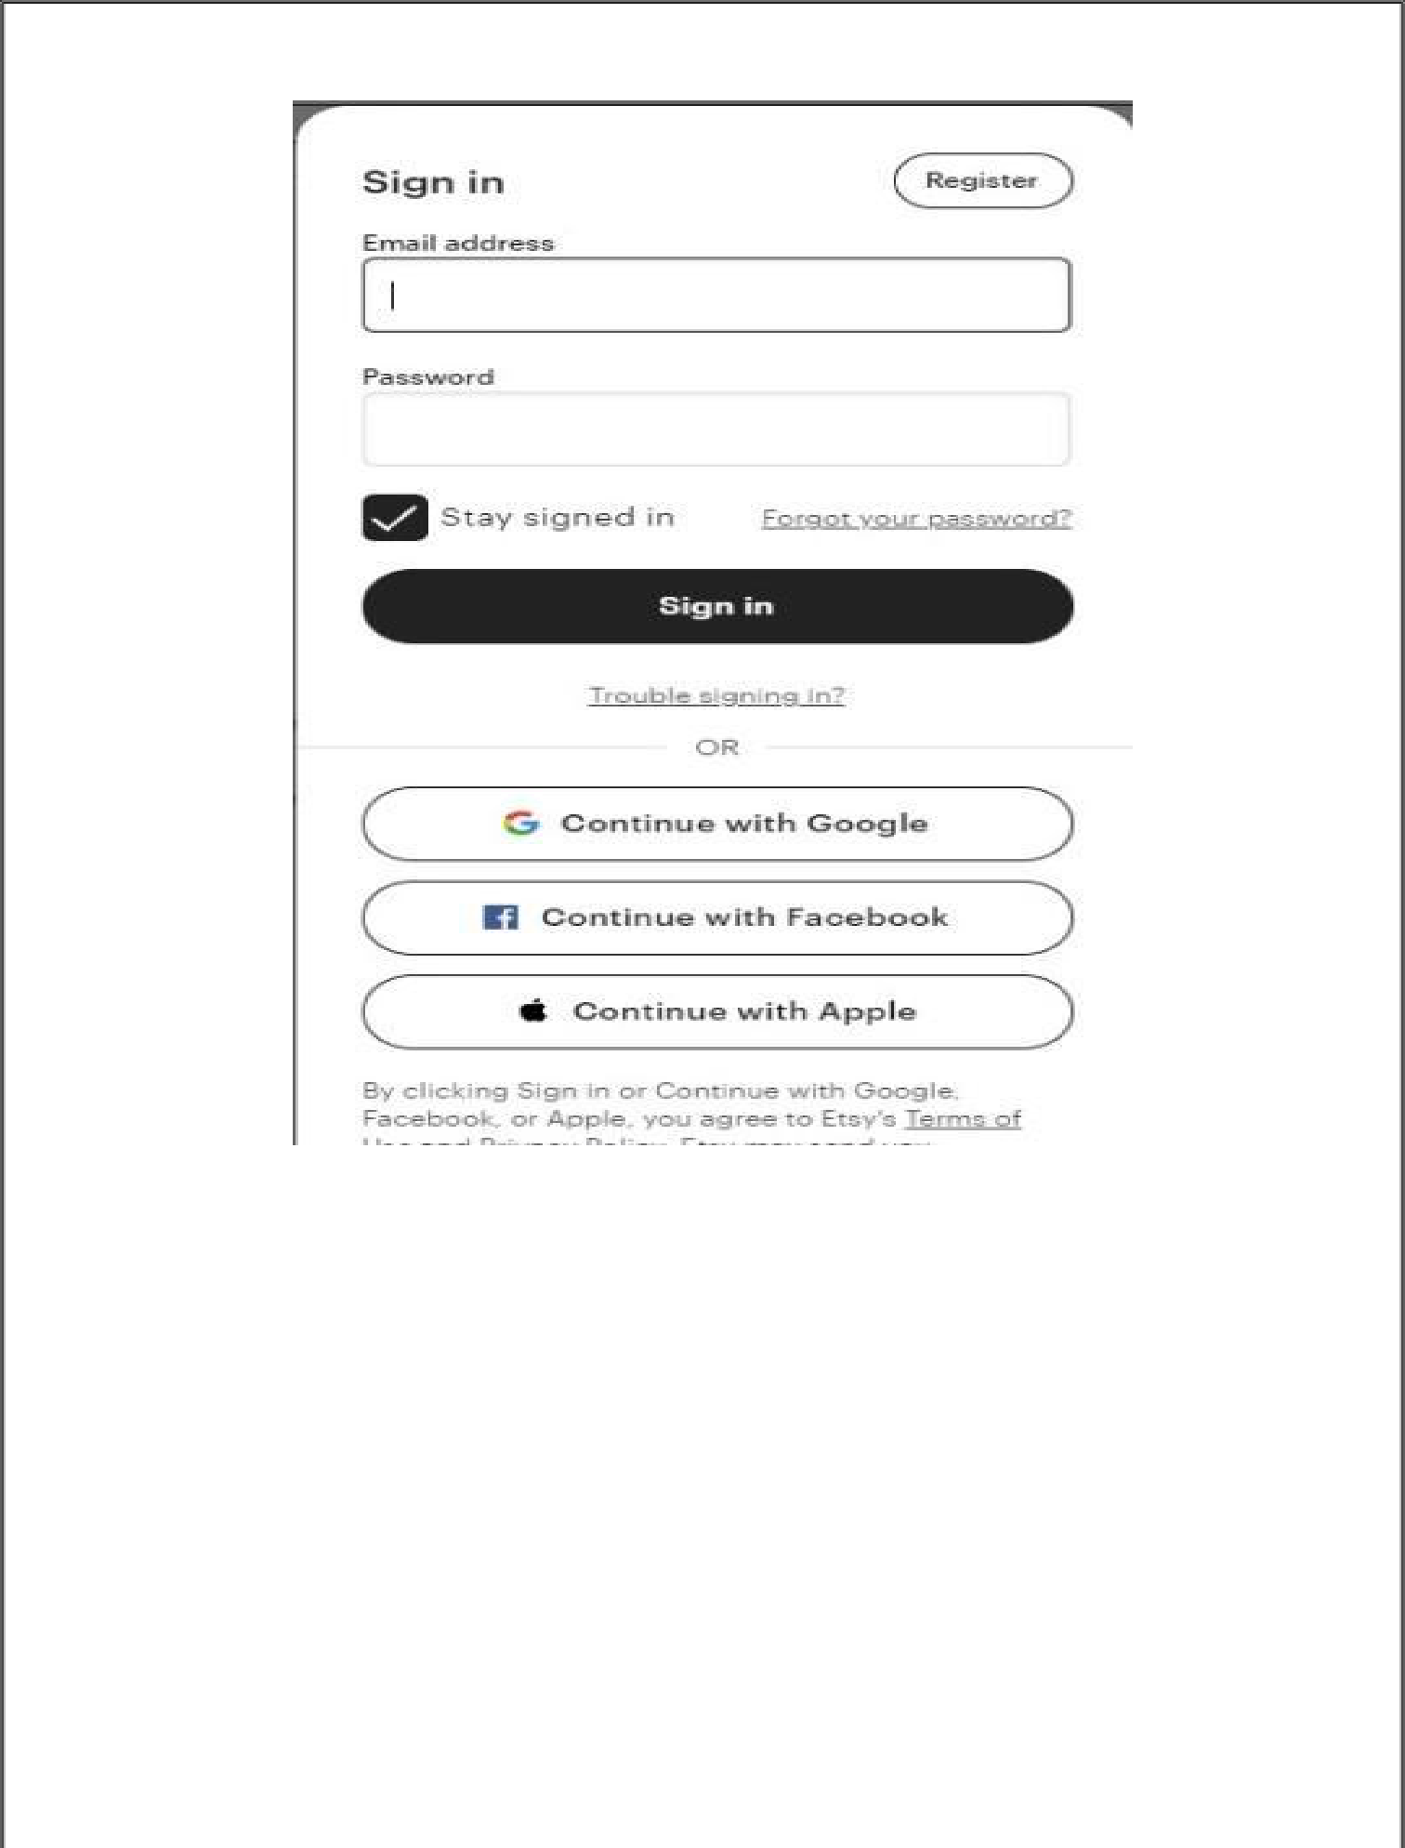

(Sign Up Form)

Page 9 of 12

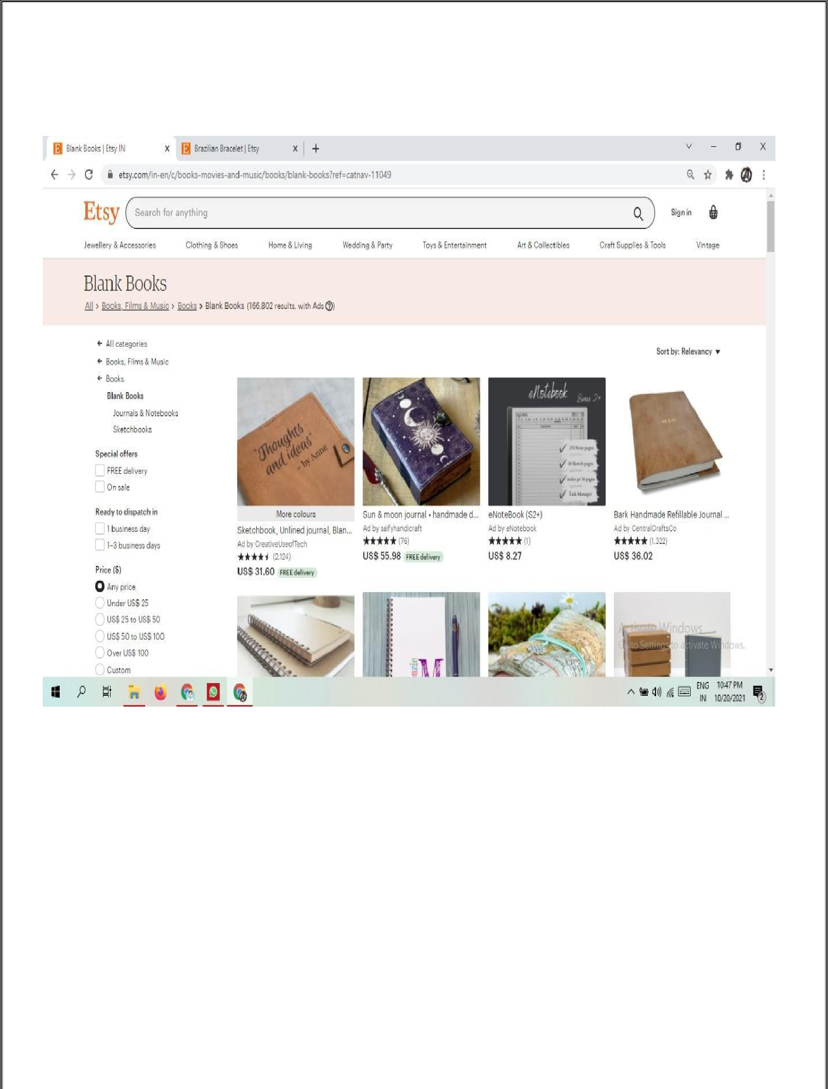

(Home Page)

Page 10 of 12

**Future Scope**

 Ecommerce business is a platform where one can buy and sell products through the internet.

 This gigantic growth in the internet has increased the ecommerce business opportunities in India. The reason behind the growth is

**online shopping.**

 Our website provides an ease of online shopping. It is home to a universe of special, extraordinary items, from unique handicrafts to vintage treasure.

 Big Online shopping platforms sell every kind of stuff and it is hectic for people to get what they want. We specialise in selling special items which people want for their house, giving gifts to their loved ones and many more.

Page 11 of 12

**Reference**

* **Book References:**
* JavaScript: The Complete Reference Powell, Thomas A. By Schneider
* Fundamentals Of Database System By Durvasula V.L.N. Somayajulu
* **Online References:**
  + www.w3schools.com
  + www.betalabs/youtube.com
  + www.mdn.com
  + https://github.com
  + https://stackoverflow.com
* **Faculty Guidelines:**

**Mr. Sharad Gupta**

**(Assistant Professor, GLA University)**

**Mr. Akash Chaudhary**

**(Assistant Professor, GLA University)**

Page 12 of 12

**Mid Term Project Report Till Date: - 15/11/21.**

**Index File**

<!DOCTYPE html>

<html lang="en">

<head>

    <meta charset="UTF-8">

    <meta http-equiv="X-UA-Compatible" content="IE=edge">

    <meta name="viewport" content="width=device-width, initial-scale=1.0">

    <title>PRAK</title>

    <link rel="stylesheet" href="style.css">

    <script src="https://kit.fontawesome.com/fa28b20391.js" crossorigin="anonymous"></script>

</head>

<body>

  <nav class ="navbar">

    <div class="nav">

      <h1>PRAK</h1>

      <div class="nav-items">

        <div class="search">

            <input type="text" class="search-box" placeholder="Search-unique">

            <button class="search-btn"> Search</button>

        </div>

        <a href="#"><img src="user.png" alt=""></a>

        <a href="#"><img src="cart.png" alt=""></a>

      </div>

    </div>

  </nav>

    <div class="menu">

        <ul>

           <li>

              <a href="#"></i>Jewellery<i class="fa fa-caret-down"></i></a>

                  <div class="dropdown1">

                        <ul>

                            <li><a href="viewmore1-1.html">Rings</a></li>

                            <li><a href="viewmore1-2.html">Necklace</a></li>

                            <li><a href="viewmore1-3.html">earings</a></li>

                            <li><a href="viewmore1-4.html">Braclets</a></li>

                        </ul>

                    </div>

            </li>

            <li>

                <a href="#">Clothing<i class="fa fa-caret-down" ></i></a>

                    <div class="dropdown1">

                        <ul>

                            <li><a href="viewmore2-1.html">Women's</a></li>

                            <li><a href="viewmore2-2.html">Men's</a></li>

                            <li><a href="viewmore2-3.html">Kid's</a></li>

                            <li><a href="viewmore2-4.html">Old people</a></li>

                        </ul>

                    </div>

            </li>

            <li>

                <a href="#">Footwear<i class="fa fa-caret-down" ></i></a>

                    <div class="dropdown1">

                        <ul>

                            <li><a href="viewmore3-1.html">Men's </a></li>

                            <li><a href="viewmore3-2.html">Women's</a></li>

                            <li><a href="viewmore3-3.html">Kid's</a></li>

                            <li><a href="viewmore3-4.html">Kohlapuri</a></li>

                        </ul>

                    </div>

            </li>

            <li>

                <a href="#">Vintage <i class="fa fa-caret-down" ></i></a>

                    <div class="dropdown1">

                        <ul>

                            <li><a href="viewmore4-1.html">Telephone</a></li>

                            <li><a href="viewmore4-2.html">Telescope </a></li>

                            <li><a href="viewmore4-3.html">Gramophone</a></li>

                            <li><a href="viewmore4-4.html">Handicraft</a></li>

                        </ul>

                    </div>

            </li>

            <li>

                <a href="#">Gift items<i class="fa fa-caret-down" ></i></a>

                    <div class="dropdown1">

                        <ul>

                            <li><a href="viewmore5-1.html">Wallet</a></li>

                            <li><a href="viewmore5-2.html">Watch</a></li>

                            <li><a href="viewmore5-3.html">Charcuterie</a></li>

                            <li><a href="viewmore5-4.html">Custom Name Necklace</a></li>

                        </ul>

                    </div>

            </li>

        </ul>

    </div>

  <div class="marquee">

<marquee>25% OFF ON FIRST PURCHASE</marquee>

  </div>

  <middle class="container1">

    <div class="first">

      <div class = "container2">

        <div class="images">

            <img src="rings.jpg" width="80%" height="75%">

            Handmade Rings

            <br>

            <button class="btn"><a href="viewmore1-1.html">View More</a></button>

        </div>

        <div class="images">

            <img src="necklace.jpg" width="100%" height="75%">

             Handmade Necklace

            <br>

            <button class="btn"><a href="viewmore1-2.html">View More</a></button>

        </div>

        <div class="images">

            <img src="earings.jpg" width="100%" height="75%">

           Handmade Earrings

            <br>

            <button class="btn"><a href="viewmore1-3.html">View More</a></button>

        </div>

        <div class="images">

            <img src="bangles.jpg" width="100%" height="75%">

           Handmade Bangles

            <br>

            <button class="btn"><a href="viewmore1-4.html">View More</a></button>

        </div>

        <div class="images">

            <img src="purse.jpg" width="100%" height="75%">

           Handmade Bags and Purses

            <br>

            <button class="btn"><a href="viewmore1-5.html">View More</a></button>

        </div>

    </div>

    </div>

    <div class="second">

      <div class = "container3">

        <div class="images">

            <img src="https://encrypted-tbn0.gstatic.com/images?q=tbn:ANd9GcS5MpRjYORCUlqzCcs4oqq6xUM7zOxUgNoj1Q&usqp=CAU" width="100%" height="75%">

             Men's Traditional Kurta <br>

            <button class="btn"><a href="viewmore2-1.html">View More</a></button>

        </div>

        <div class="images">

            <img src="https://encrypted-tbn0.gstatic.com/images?q=tbn:ANd9GcRbNyWEoo7ycMkUECRi71AKZiSomoEnwNiiig&usqp=CAU" width="100%" height="75%">

            Women's Traditional Saree

            <br>

            <button class="btn"><a href="viewmore2-2.html">View More</a></button>

        </div>

        <div class="images">

            <img src="https://encrypted-tbn0.gstatic.com/images?q=tbn:ANd9GcTqbdCk1r4hrPmobaU5wYY3pk1bRUXpAiqanQ&usqp=CAU" width="100%" height="75%">

            Kids Traditional Wear

            <br>

            <button class="btn"><a href="viewmore2-3.html">View More</a></button>

        </div>

        <div class="images">

            <img src="https://encrypted-tbn0.gstatic.com/images?q=tbn:ANd9GcQuxkHcokMz26VKamz1bi2oYHZfnZB-ohvROg&usqp=CAU" width="100%" height="75%">

            Old Age Group Wear

            <br>

            <button class="btn"><a href="viewmore2-4.html">View More</a></button>

        </div>

    </div>

    </div>

    <div class="third">

      <div class = "container">

        <div class="images" style="width: 55%;">

            <img src="men slipper.jpg" width="100%" height="75%">

            Men's Handmade

            <br>

            <button class="btn"><a href="viewmore3-1.html">View More</a></button>

        </div>

        <div class="images" >

            <img src="ladie slipper.jpg" width="80%" height="75%"><br>

            Ladies Handmade

            <br>

            <button class="btn"><a href="viewmore3-2.html">View More</a></button>

        </div>

        <div class="images">

            <img src="shoe kid.jpg" width="80%" height="75%"><br>

            Kid's Handmade

            <br>

            <button class="btn"><a href="viewmore3-3.html">View More</a></button>

        </div>

        <div class="images">

            <img src="kohlapuri.jpg" width="100%" height="75%">

            Kohlapuri Chhapal Handmade

            <br>

            <button class="btn"><a href="viewmore3-4.html">View More</a></button>

        </div>

    </div>

    </div>

    <div class="fourth">

      <div class = "container4">

        <div class="images" style="width:45%" >

            <img src="telephone.jpg" width="100%" height="75%"><br>

            Antique Telephone Home Décor Vintage Items Made of Wood with Brass Work<br>

            <button class="btn"><a href="viewmore4-1.html">View More</a></button>

        </div>

        <div class="images">

            <img src="telescope.jpg" width="100%" height="75%">

            VINTAGE TELESCOPE AND COMPAS<br>

            <button class="btn"><a href="viewmore4-2.html">View More</a></button>

        </div>

        <div class="images" style="width: 50%;">

            <img src="gramophone.jpg" width="80%" height="75%">

            Gramophone Record Player Original Working Antique Vintage Phonograph<br>

            <button class="btn"><a href="viewmore4-3.html">View More</a></button>

        </div>

        <div class="images" style="width: 50%;">

            <img src="handicraft.jpg" width="80%" height="75%"><br>

            Brk Handicraft Premium Antique Items Brass Decorative Wine Set Showpiece Home Decor Decoration Gift -Vintage Collective<br>

            <button class="btn"><a href="viewmore4-4.html">View More</a></button>

        </div>

    </div>

    <br><br>

    </div>

    <div class="fifth">

      <div class = "container">

        <div class="images">

            <img src="gift1.jpg" width="100%" height="65%">

            Anniversary Gift for Him,Personalized Wallet,Mens Wallet,Engraved Wallet,Leather Wallet<br>

            <button class="btn"><a href="viewmore5-1.html">View More</a></button>

        </div>

        <div class="images">

            <img src="gift2.jpg" width="100%" height="65%">

            Anniversary Gift for Him,Wood Watch,Personalized Watch,Engraved Watch,Wooden Watch<br>

            <button class="btn"><a href="viewmore5-2.html">View More</a></button>

        </div>

        <div class="images">

            <img src="gift3.jpg" width="100%" height="65%">

            Personalized Charcuterie Planks and Beer Flights - 4 Styles and Gift Sets Available for Cooking<br>

            <button class="btn"><a href="viewmore5-3.html">View More</a></button>

        </div>

        <div class="images">

            <img src="gift4.jpg" width="100%" height="65%">

            Custom Name Necklace with Birth Flower,Dainty Personalized Minimalist Jewelry<br>

            <button class="btn"><a href="viewmore5-4.html">View More</a></button>

        </div>

    </div>

    </div>

  </middle>

  <br>

  <br>

  <br>

  <div class="bottom-mid">WHAT IS PRAK ?</div>

  <br>

  <h3><a href="">Read our wonderfully weird story</a></h3>

  <br>

  <div class="main">

    <div class="outer">

      <h4>Organisation for handmade </h4><br>

        <p> Prak is an Indian Based e-commerce website which is a go-to trending b2b site for millions of makers of handmade goods,vintage items and craft products.It is a small start up where people will come together go buy items and surely take advantage of it.</p>

          <strong><a href=""><u>Here are some of the ways we’re making a positive impact, together.</u></a></strong>

    </div>

    <div class="outer1">

      <h4>Efficient Creators</h4><br>

        <p>There's no Prak warehouse just few of people selling the things they love.we make the whole process easy,helping you connect directly with makers to find something extraordinary.</p>

    </div>

    <div class="outer2">

      <h4>Composure</h4><br>

        <p>Your Privacy is the highest priority of our dedicated team,and if you ever need assistance, we are always ready to step in for support.</p>

    </div>

  </div>

  <br>

  <br>

  <br>

  <footer class="footer">

    <div class="contain">

        <div class="row">

        <div class="foot-col">

        <h3>The Company</h3>

        <ul>

            <li><a href="#">Prak-in</a></li>

            <li><a href="#">Our Story</a></li>

            <li><a href="Termsofuse.html">Terms Of Use</a></li><!-- terms of use -->

            <li><a href="https://www.google.com/maps/embed?pb=!1m18!1m12!1m3!1d448916.46637213975!2d77.02115597496018!3d28.47473097589749!2m3!1f0!2f0!3f0!3m2!1i1024!2i768!4f13.1!3m3!1m2!1s0x390cddb5f03b5b71%3A0x391747e4bedfcb19!2sHaldiram&#39;s!5e0!3m2!1sen!2sin!4v1622612697128!5m2!1sen!2sin" target="iframe_a">Site Map</a></li>

            <li><iframe src="" name="iframe_a" width="300" height="200" style="border:0;" allowfullscreen="" loading="lazy"></iframe>

           </ul>

        </div>

      <div class="foot-col">

        <h3>Guide</h3>

              <ul>

            <li><a href="#">How To Buy</a></li>

            <li><a href="#">How To Sell</a></li>

           </ul>

        </div>

      <div class="foot-col">

        <h3>Apple-Pie Order</h3>

        <ul>

            <li><a href="bulkorder.html">Bulk Orders</a></li>

            <li><a href="affilates.html">Affilates</a></li>

       </ul>

    </div>

      <div class="foot-col">

        <h3>Help & Support</h3>

        <ul>

            <li><a href="contactUs.html">Contact Us</a></li>

            <li><a href="FAQ.html">FAQ's</a></li>

            <li><a href="privacypolicy.html">Privacy Policy</a></li>

            <li><a href="termsnconditions.html">Terms & Conditions</a></li>

           </ul>

        </div>

</div>

</div>

<div class="foot1">

<p>Register for Free - <a href="#">  Signup!</a></p>

</div>

<div class="foot2">

<ul>

    <a href="mailto:prakhub.inc@gmail.com"><i class="fa fa-envelope"></i></a>

    <a href="https://www.telegram.com/9170852086"><i class="fab fa-telegram"></i></a>

    <a href="https://www.instagram.com/"><i class="fab fa-instagram"></i></a>

    <a href="https://twitter.com/home"><i class="fab fa-twitter"></i></a>

</ul>

</div>

  <div class="foot3">

    <p>Copyright &copy; 2021 All Rights by Prakhub.inc</p>

  </div>

</body>

</html>

**Index.css File**

*{

    margin:0;

    padding:0;

    box-sizing: border-box;

    font-family: 'roboto', sans-serif;

}

.navbar{

    position:sticky;

    top:0;

    left:0;

    width:100%;

    background: #f5f5f5;

    z-index: 9;

}

.nav{

    padding: 10px 10vw;

    display:flex;

    justify-content: space-between;

}

h1{

    height:60px;

    font-size: 35px;

    display: flex;

    align-items: center;

}

h3{

    text-align:center;

    font-size: 30px;

}

.bottom-mid{

    font-size: 50px;

    font-weight: bold;

    text-align: center;

}

.nav-items{

    display: flex;

    align-items: center;

}

.search{

    width: 910px;

}

.search-box{

    width: 70%;

    height: 40px;

    border-top-left-radius:10px;

    border-bottom-left-radius:10px;

    border: 1px solid #d1d1d1;

    padding: 20px;

    text-transform: capitalize;

    background: none;

    color: #ddd5d5;

    outline: none;

}

.search-btn{

    width: 20%;

    height: 40px;

    padding: 10px 20px;

    border: none;

    outline: none;

    cursor: pointer;

    background: #383838;

    color: #fff;

    text-transform: capitalize;

    font-size: 15px;

    border-top-right-radius:10px;

    border-bottom-right-radius:10px;

}

.nav-items a{

    margin-left: 20px;

}

.nav-items a img{

    width: 30px;

}

.menu{

    background-color: rgb(50, 50, 50);

    text-align: center;

}

.menu ul{

    list-style: none;

    display: inline-flex;

}

.menu ul li{

    width: 150px;

    margin: 10px;            /*   providing margin,space and padding for menu in black backgorund*/

    padding: 15px;

}

.menu ul li a{

    text-decoration: none;

    text-transform: uppercase;     /* Menu word color, font and removing hyperlink display*/

    color: white;

    font-family: arial;

}

.fa{

margin-left: 5px;                  /* icon spacing*/

}

.menu ul li:hover{

    background-color: tomato;   /* hover color */

}

.dropdown1{

display: none;               /* dropdown menu  aka submenu display is removed*/

}

.menu ul li:hover .dropdown1{

    display: block;

    position: absolute;

    background-color: rgb(50, 50, 50);

    margin-top: 15px;                             /* postitioning of submenu */

    margin-left: -25px;                           /* positioning of submenu*/

}

.menu ul li:hover .dropdown1 ul               {

    display: block;               /* submenu becomes verical in line*/

}

.menu ul li:hover .dropdown1 ul li{

    background: transparent;                          /* submenu hover color removed and underline added */

    border-bottom: 1px solid tomato;

    width: 150px;

}

.menu ul li:hover .dropdown1 ul li a:hover{

    color: tomato;              /* submenu words coloured*/

}

.marquee{

    border: 1px solid black;

    color: red;

    height: 50px;

    padding-top: 10px;

    font-size: 20px;

}

.first{

    border: 1px solid yellowgreen;

    height: 60vh;

}

.second{

    border: 1px solid yellowgreen;

    height: 60vh;

}

.third{

    border: 1px solid yellowgreen;

    height: 70vh;

}

.fourth{

    border: 1px solid yellowgreen;

    height: 7 0vh;

    display: flex;

    flex-direction: row;

    justify-content: center;

    align-items: center;

    margin-bottom: 50px;

}

.fifth{

    border: 1px solid yellowgreen;

    height: 60vh;

}

.main{

    display: flex;

    height: 300px;

    background-color: cornflowerblue;

}

.outer{

    text-align: center;

    padding: 3%;

    justify-content: center;

    width: 50%;

}

.outer1{

    text-align: center;

    padding: 3%;

    justify-content: center;

    width: 50%;

    font-size: 20px;

}

.outer2{

    text-align: center;

    padding: 3%;

    justify-content: center;

    width: 50%;

    font-size: 20px;

}

body{

    background-position:center;

    background-size:cover;

    background-repeat: no-repeat;

    height:100vh;

}

/*

.footer{

    background-color: #b9b5b5;

    height: 275px;

    display: flex;

    flex-direction: row;

}

.tag-line{

    width: 500px;

    padding: 20px;

    margin-left: 0px;

    padding-top: 70px;

}

.company{

    width: 400px;

    margin-left: px;

    padding-left: 100px;

    padding-right: 50px;

    padding-top: 20px;

}

.guide{

    width: 400px;

    margin-left: px;

    padding-left: 100px;

    padding-right: 50px;

    padding-top: 20px;

}

.help-support{

    width: 400px;

    padding-left: 100px;

    padding-right: 50px;

    padding-top: 20px;

}

*/

body{

    background-color:rgb(218, 213, 213);

    text-align: center;

}

h3{

    color:darkgray;

}

.container{

    display: flex;

    flex-direction: row;

}

.btn{

    margin-top:20px;

}

.container3{

    display: flex;

    flex-direction: row;

}

.container2{

    display: flex;

    flex-direction: row;

}

.btn{

    margin-top:20px;

}

.images{

    margin: 4px;

    background-size:cover;

    box-shadow: black 0 0 30PX;

}

.btn a

{

    text-decoration: none;

    color: black    ;

}

.foot3{

    background-color: #383838 ;

    color: white;

    padding-top: 14px;

    height:8vh;

    width: 10bh;

}

.container4 {

    display: flex;

    flex-direction: row;

}

.contain

{

     max-width: 1270px;

     margin: auto;

}

.row

{

    display: flex;

    flex-wrap: wrap;

}

ul

{

    list-style: none;

}

.footer

{

    background-color: #24262b;

    padding: 70px 0px;

}

.foot-col

{

     width: 25%;

     padding: 0 20px;

}

.foot-col h3

{

    font-size: 18px;

    color: #ffffff;

    text-transform: capitalize;

    margin-bottom: 35px   ;

    font-weight: 500;

    position: relative;

}

.foot-col h3::before

{

    content: '' ;

    position: absolute;

    left:90px ;

    bottom: -12px;

    background-color:#e91e63 ;

    height: 2px;

    box-sizing: border-box;

    width: 100px;

}

.foot-col ul li:not(:last-child)

{

    margin-bottom: 5px;

}

.foot-col ul li a

{

    font-size: 16px;

    text-transform: capitalize;

    color: #ffffff;

    text-decoration: none;

    font-weight: 300;

    color: #bbbbbb;

    display: block;

    transition: all 0.3s ease;

}

.foot-col ul li a:hover

{

    color: #ffffff;

    padding: 3px;

}

.foot1

{

    text-align: center;

    padding-top: 30px;

    font-size: 18px;

}

.foot1 a

{

    text-decoration: none;

}

.foot1 p

{

    color: #ffffff;

}

.foot2

{

justify-content: center;

display: flex;

padding-top: 30px;

padding-left: 120px;

padding-bottom: 20px;

}

.foot2 a

{

    display: inline-block;

    height: 50px;

    width: 50px;

    background-color: rgba(255,255,255,0.2);

    margin: 0 100px 20px 0;

    text-align: center;

    line-height: 50px;

    border-radius: 50%;

    color: #ffffff;

}

.foot3

{

    color: #ffffff;

}

.foot-col ul li a iframe

{

    margin-left: -100px;

}

 /* responsive*/

@media(max-width: 600px)

{

    .foot-col

    {

        width: 100%;

    }

}

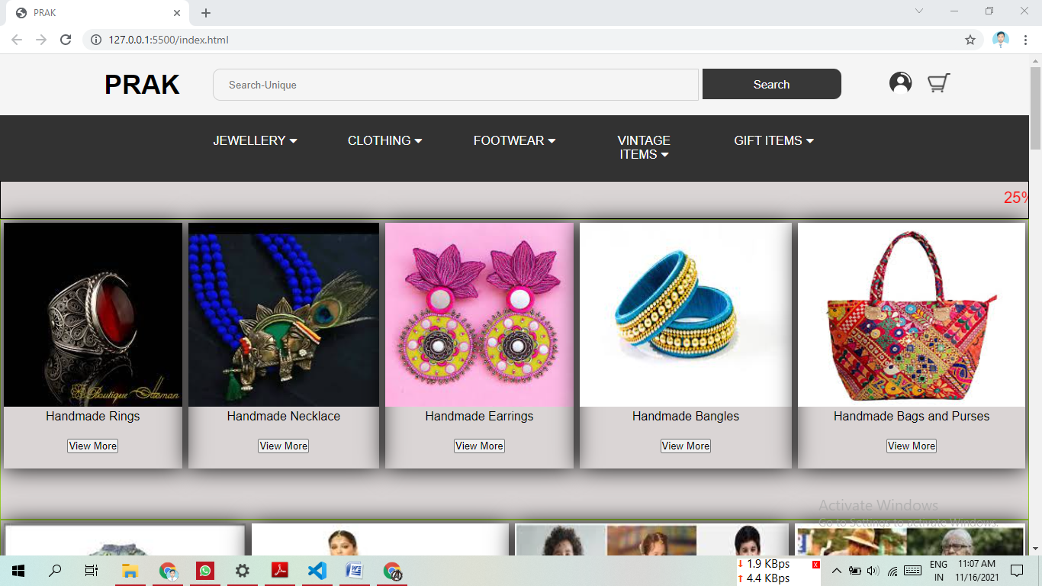

|  |
| --- |
|  |

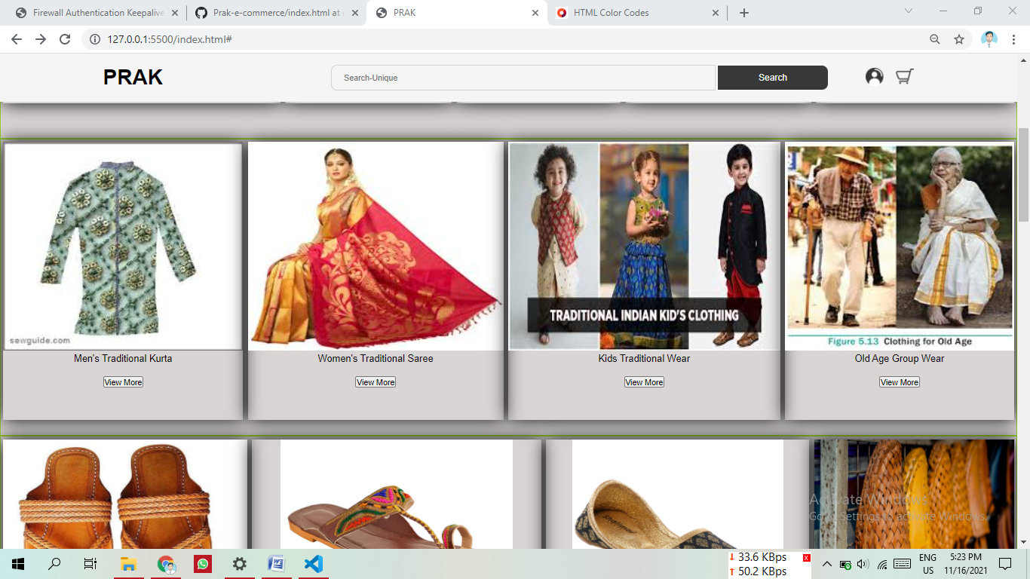

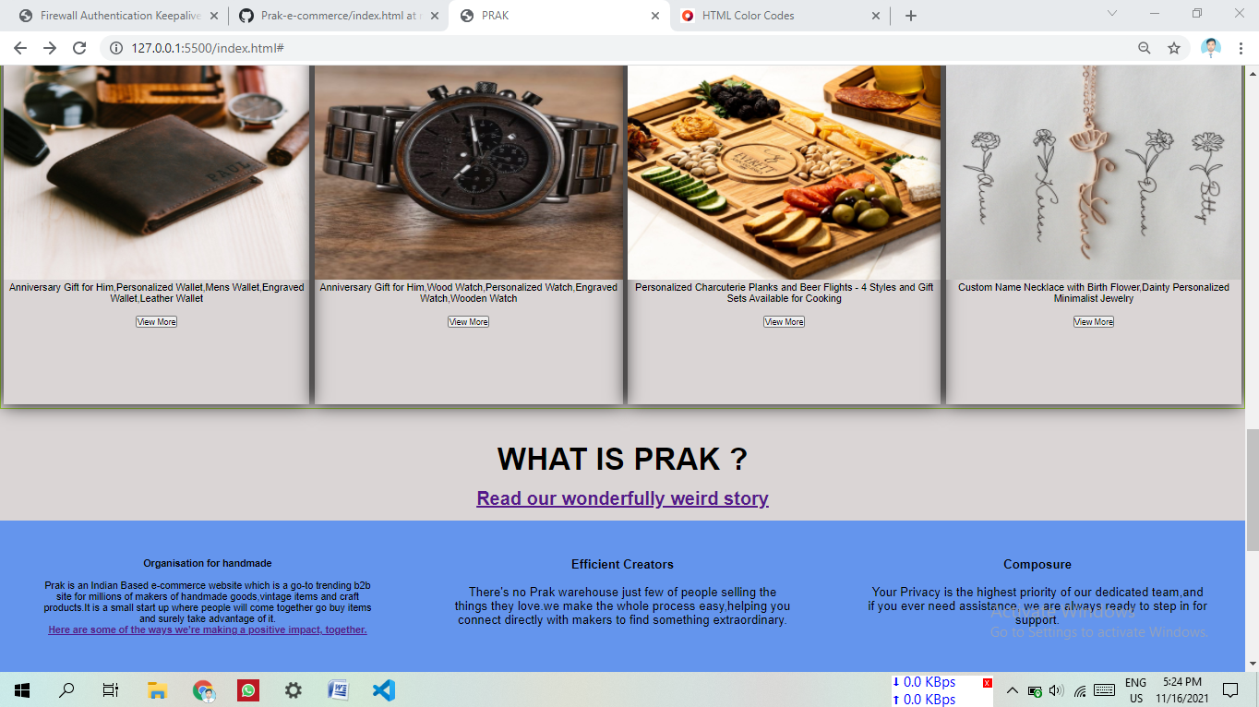

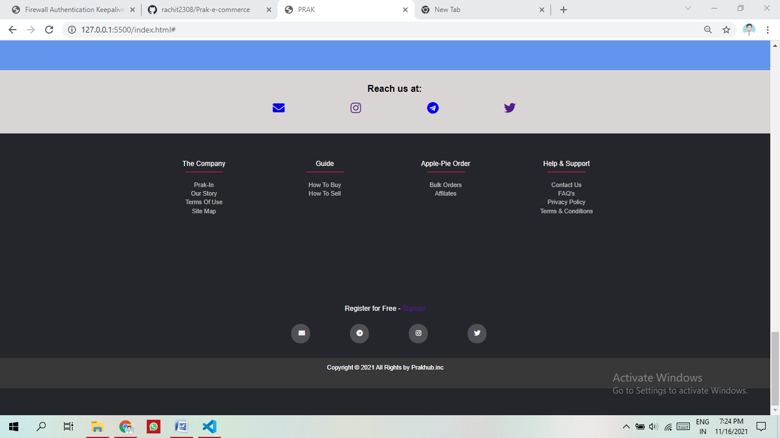

**Checkout Page File**

<html lang="en">

<head>

    <meta charset="UTF-8">

    <meta http-equiv="X-UA-Compatible" content="IE=edge">

    <meta name="viewport" content="width=device-width, initial-scale=1.0">

    <title>Document</title>

    <link rel="stylesheet" href="viewmore1.css">

</head>

<body>

    <h1>Item Details</h1>

    <div class = "container">

        <div class = "first">

            <img src="handicraft.jpg" height="100%" width="95%">

        </div>

        <div class="second">

        <pre>

            <br><br>

<h2>Brk Handicraft Premium Antique Items Brass Decorative Wine Set Showpiece</h2>

Brk Handicraft Premium Antique Items Brass Decorative Wine Set Showpiece Home Decor Decoration Gift -Vintage Collective

We are expertise in precious brass crafts. These product are designed with modern machinery and technology under the guidance of experienced ...

PRICE --₹999  <strike>₹3,995</strike> 79% off

REVIEW -- 5,172 ratings and 1000 reviews

Available offers

Bank Offer -- 5% Unlimited Cashback on Flipkart Axis Bank Credit CardT&C

Bank Offer -- 15% Instant discount on first Pay Later order of ₹500 and aboveT&C

No Cost EMI -- Bajaj Finserv EMI Card on cart value above ₹2999View Plans

EMI starting from ₹91/monthView Plans

        </pre>

        <br><br>

        Deliver to

        <input type ="number" placeholder="Enter your pincode" >

        </div>

    </div>

</body>

</html>

**Checkout Page.css File**

body{

    background-color: darkgrey;

    text-align: center;

    font-family: cursive ;

}

h1{

    color: rgb(116, 111, 73);

}

.container{

    display: flex;

    flex-direction: row;

    width: 100%;

}

.first{

    margin-top: 30px;

    width: 100%;

}

.second{

    text-align: left;

    margin-left:20px ;

}



